力扣刷题之道

### 两数之和：

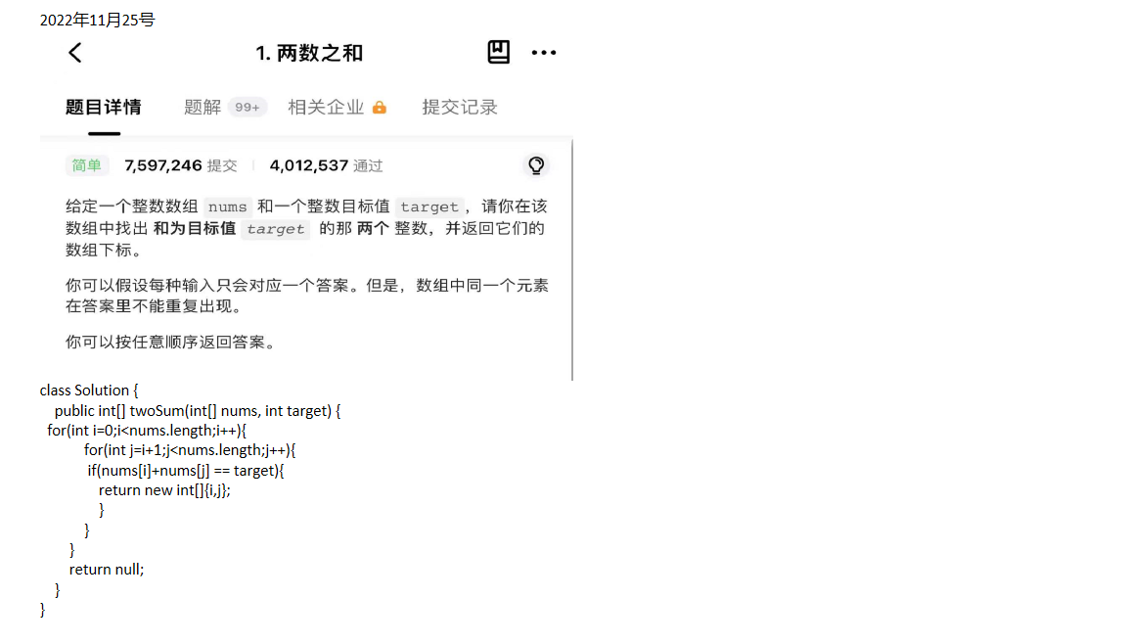

**---------------------------------------------------------------------------------------------------------------------------------**

**链表反转：**



